JS compiler

Yau Chung Lam

Date | version | Remarks
1/1/2023 | 0.1.0

Table of Content
Contents
Introduction 2
Background 2
Design 3
Overall Design 3
Compiler 3
Runtime 3
Compiler 3
Command line interface 4
Type System 4
Any Type 4
Object Type 5
Parser 5
IR-Generation 6
Runtime 7
Overview 7
Garbage collector 7
Design 7
Exception Handling 7
Design 7

Introduction

Background
Typescript is a superset of JavaScript has been slowly replacing JavaScript on the web. However, current JavaScript engines does not execute Typescript, instead the developer transpiles Typescript into JavaScript to be executed. It is certain that introduction of types boosts the performance of scripts, yet behind the scenes the JavaScript Engine speculates and generates a variety of compiled functions in different compiling stage, resulting in a huge overhead and memory usage.

Web Assembly is an assembly language that was release in 2017 introduced an alternative to JavaScript for executing programs in near native performance. Web Assembly is initially designed to run alongside JavaScript. However, the overhead of bridging JavaScript and Web Assembly is huge. In some cases, the overhead is even larger than the execution time of the assembly.

This project aims to combine the fast execution speed of Web Assembly and the Typed system of Typescript. With a Typed system introduced, memory layout of Objects is known at compile time,
Web Assembly can perform native Assembly instructions on Objects and possibly inlining functions.

This project also implements a JavaScript engine to increase compatibility for users transiting from
JavaScript to Typescript and Web Assembly.

This project uses the Rust programming language as the primary coding language.
Rust, is a programming language that features memory safety and a sophisticated build system which has gain momentum in the past few years. It is on its seventh year being the most loved language on Stack Overflow survey.

Overall Design
The project is abstracted into two main sections: the runtime and the compiler.

Compiler
The compiler takes in JavaScript or TypeScript file. It then transforms and optimise it into IR code. The IR code is then sent to the selected backend LLVM or Cranelift to be compiled into native code. This is the core of this project.

Runtime
The runtime is a static library that provides util functions that ease the compiling process of the compiler. The runtime provides functions such as creating and modifying Objects, the standard ECMA library and most importantly, the garbage collector.

Compiler

The compiler is divided into three main stages:

Parsing
Parses Typescript into AST
IR generation
generates IR code by translating AST
Machine code generation
generates Machine code from IR code

Command line interface

The command line interface is the bridge between the compiler and the user. The design of the command line interface is referenced from other compilers.

Commands:
check: Check a local package and all its dependencies for errors.
build: Compile a local package and all its dependencies.
init: Initialize a local package.
help: Print this message or the help of the given subcommand(s).

Parser
The parser should be able to parse most JavaScript and TypeScript source code that follows the ECMA standard. Due to the complexity of such parser, a third-party parser will be used.
The parser also determines dependencies after parsing each module and bundle them together into a single package. This package will be consisted of a single AST tree that represents the programme and a source-map that contains debugging information.
Modules are resolved into a single AST bundle during parsing. This allows further optimisations in the upcoming stages. The dependency can be imported from a local area (current source directory) or from a trusted git source.
The Source of dependency is determined by the following logic:

Input (String)

Starts with “./”?
Yes
Load from local file

No

Yes
Load from web or cache
Starts with “http” or “https”?

No

Panic

Once the module is loaded, it is parsed by the parser. During the bundling process, the following conditions are met.
- Each module can only be executed once.
- If a module is imported as an Object, the exported variable of that module must be synchronised with the Object’s properties.
- Cyclic dependencies are forbidden and will issue a panic if detected.

IR-Generation
The IR generator is the next stage of compilation after parsing. The Generator takes in an AST package and outputs an IR package.

Runtime

Overview

The runtime provides necessary functions for operations to run. Most significant is the Garbage Collector and the exception handling routine.

Garbage collector

Design
This garbage collector is designed with lightweight and performance in mind. The goal of the garbage collector is to detect memory that are no longer reachable and return it to the allocator for future reuse.
This garbage collector will be a hybrid conservative-tracing GC. The design philosophy is highly referenced from webpack’s GC and V8’s Olipan GC. This GC will implement logical versioning for pointer marking and dynamic dispatch for root tracing.
The memory allocator is a bump allocator that increments its cursor every time it allocates. The garbage collection routine is responsible for setting the cursor’s position in case more free space is available.

Memory allocator
Memory allocators and GCs are tightly coupled by nature – the allocator allocates memory to be reclaimed by the GC, and the GC frees memory to be reused by the allocator.
Fixed-sized bump allocators are used for allocations smaller than 2048 Bytes, that is, an allocator that only allocates memory chunks of some fixed size. The allocator keeps track of a list of blocks. Each block contains 4 pages which is 16KB (4096 * 4). Each block is divided into cells of size, and has a header at its start, which contains metadata needed for the GC and allocation, e.g., which cells are free. By aggregating and sharing metadata at the footer, it both saves memory and improves performance of related operations.

Implementation

Memory allocators

Heap
The Heap data structure is the core component of the memory allocators. It has a fixed sized cell type and maintains references to a list of blocks.
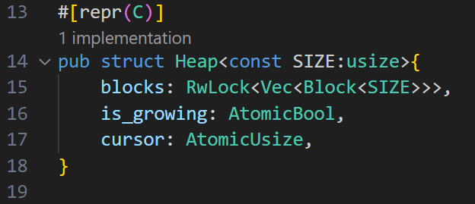
Iron-gc/src/heap.rs

The Heap data structure has the following functions:
Heap::new
Heap::about_to_mark
Heap::grow
Heap::allocate
Heap::sweep
Heap::clean

Function Heap::new
This is a constant function meaning that it is evaluated at compile time. The #[inline] attribute give hint to the rust compiler that this function should be inlined.
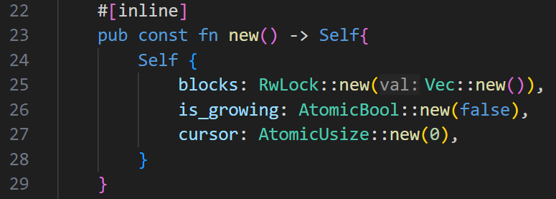

Function Heap::about_to_mark
This function takes in a reference to heap and a Boolean indicating if the preparation for marking is a young gc.
It acquires a read guard on the list of blocks, loop through them to prepare blocks for marking. Only the last four blocks are prepared if it is a young gc.
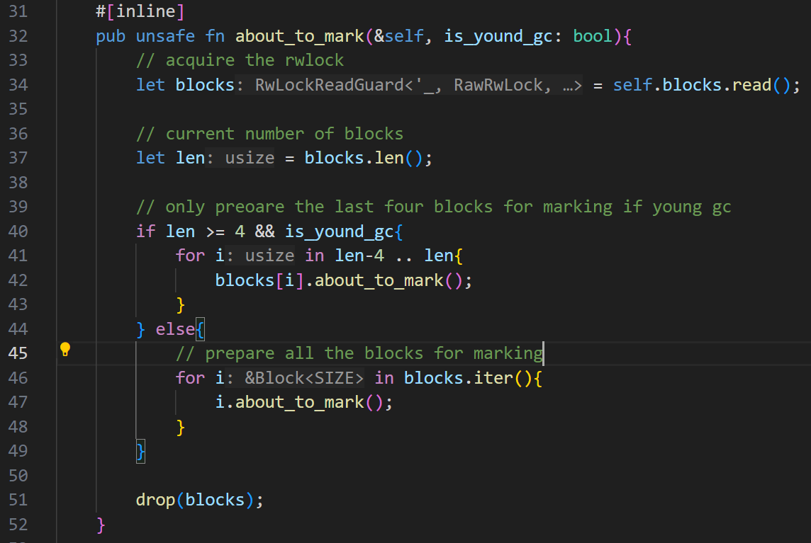

Function Heap::grow
This function takes in a reference to the Heap and grows a block to the list. It also determines if a Garbage collection should be triggered.
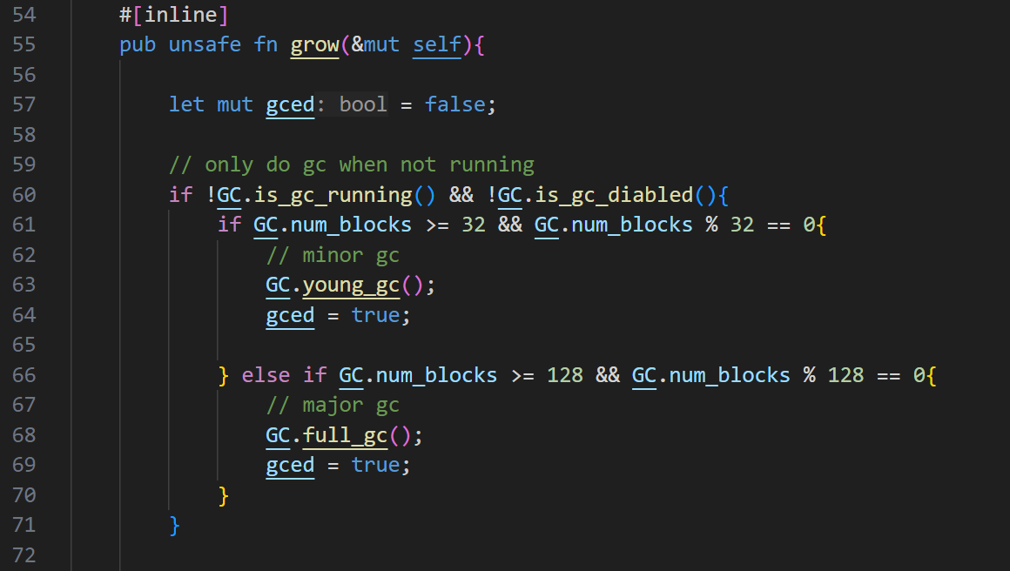
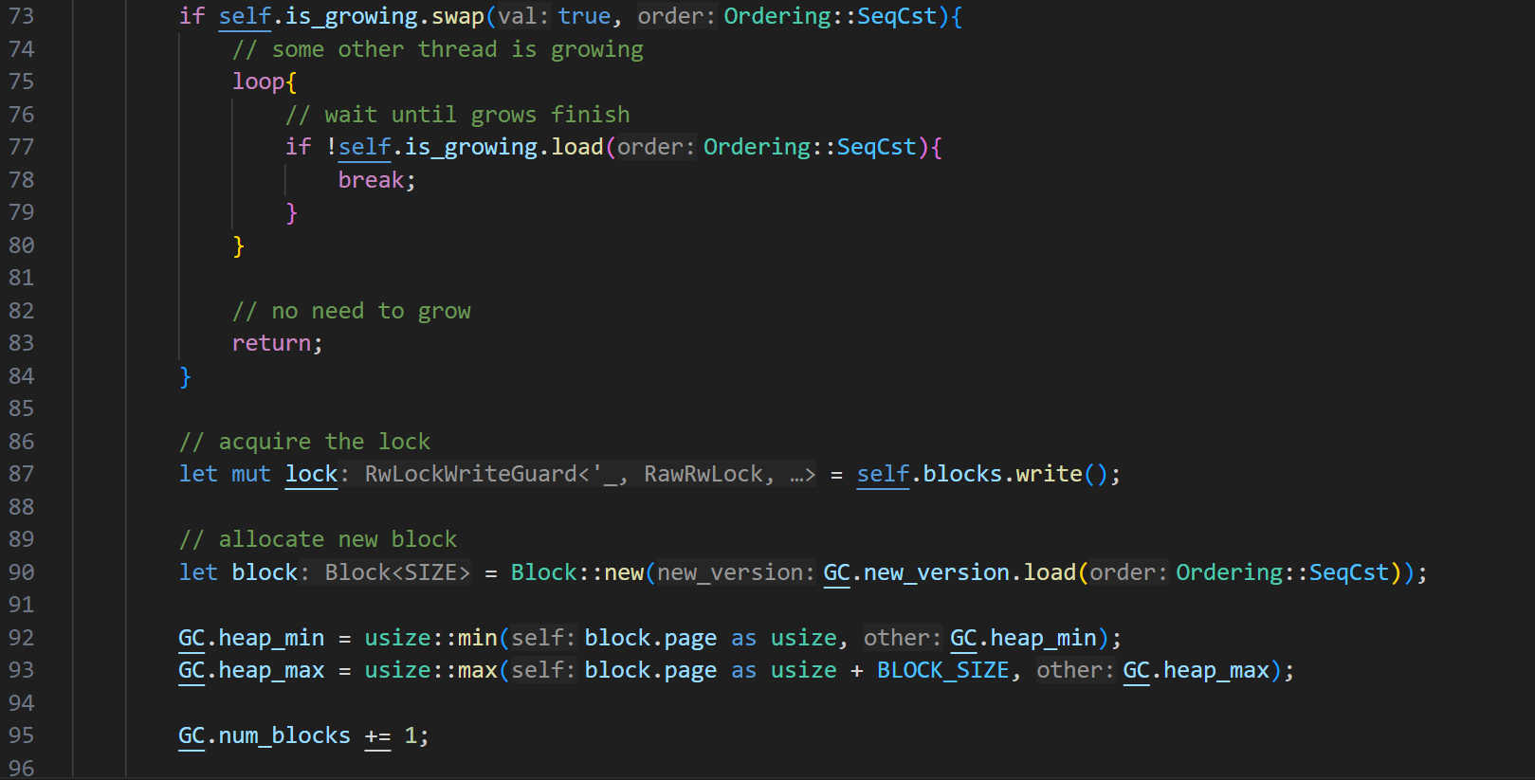
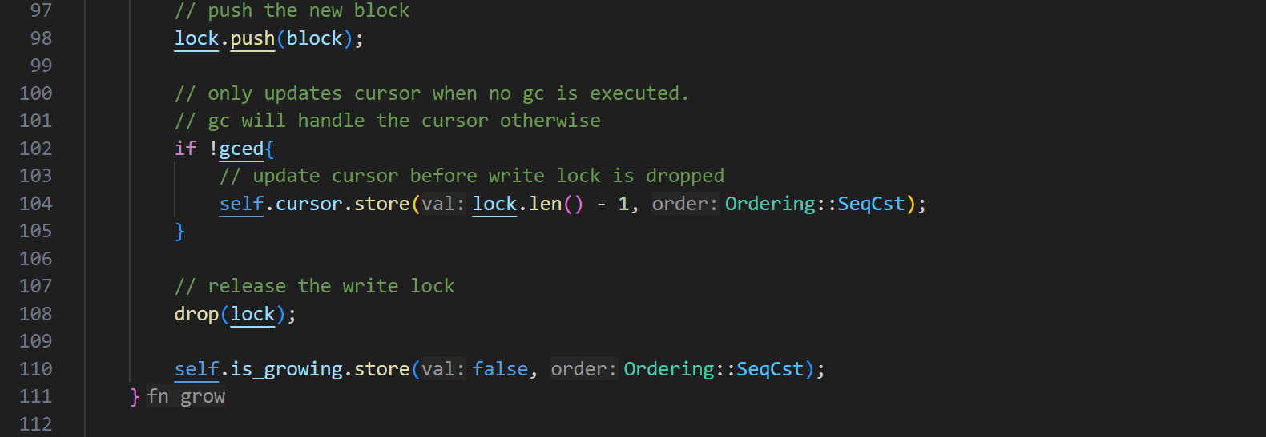

Function Heap::allocate
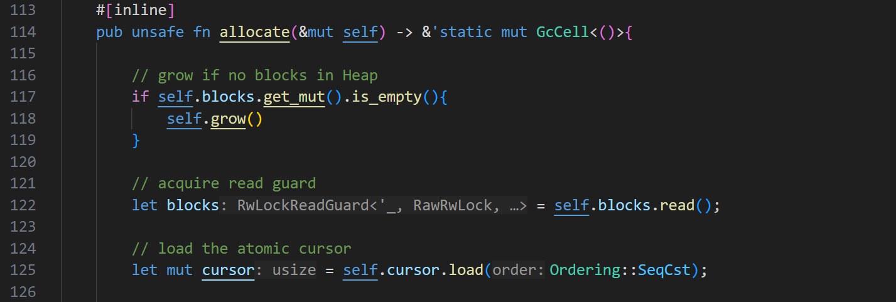
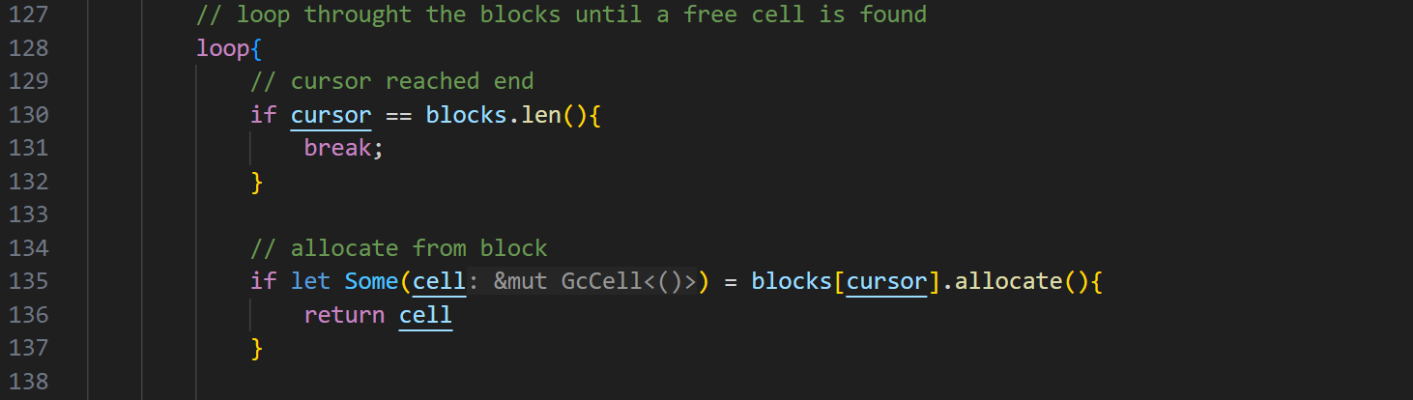
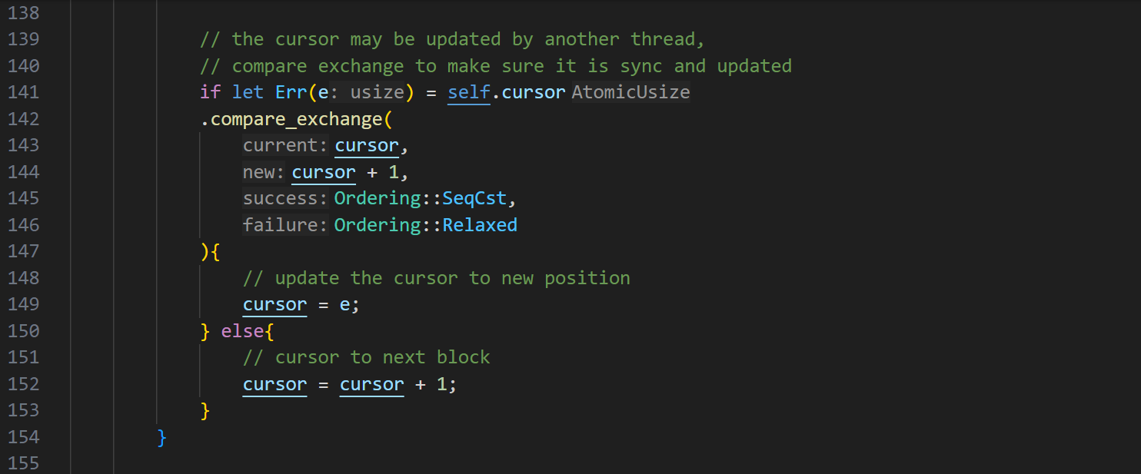
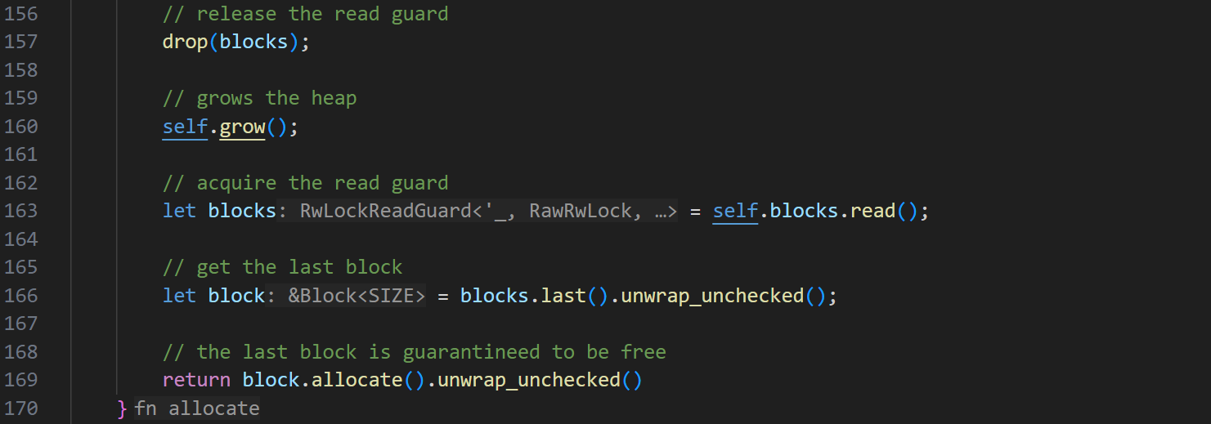

The garbage collector Type System

Any Type
Nan boxing is used by the JavaScript engine as a technique to allow any dynamic type to be contained in a 64bit float.

When the value is not a number, the first 16 bit is used to identify the type and the last 48 bit is used to store data such as pointers or symbols.

The basic data types include number, bigint, string, symbol, object, undefined and null.

Sign bit NaN bits Pointer bits

According to the IEEE-754, any value that has its 12 bits high starting from the second bit is a Nan value, this leaves us 52bits to use with.
In our NaN boxing implementation, 1bit is the quiet NaN bit, 3bits are used as a tag and 48bits for pointer.
Since 2 ^ 3 == 8, exactly 8 types can be stored in a NaN box.
Any value that is not a NaN is a number.

Object Type
An Object is virtually a Map that stores keys and values.

Exception Handling

Design
The exception handling in the runtime follows the Itanium ABI. By using Libunwind and LLVM’s built-in support, the exception routine is zero-cost and is compatible with most foreign languages that follows the C standard.

Type System

Any Type
Nan boxing is used by the JavaScript engine as a technique to allow any dynamic type to be contained in a 64bit float.

When the value is not a number, the first 16 bit is used to identify the type and the last 48 bit is used to store data such as pointers or symbols.

The basic data types include number, bigint, string, symbol, object, undefined and null.

Sign bit NaN bits Pointer bits

According to the IEEE-754, any value that has its 12 bits high starting from the second bit is a Nan value, this leaves us 52bits to use with.
In our NaN boxing implementation, 1bit is the quiet NaN bit, 3bits are used as a tag and 48bits for pointer.
Since 2 ^ 3 == 8, exactly 8 types can be stored in a NaN box.
Any value that is not a NaN is a number.

Object Type
An Object is virtually a Map that stores keys and values.

